# **Chapter 5: Risk Management**

Risk Management can be defined as identifying and managing the threat. It helps in reducing problems that might affect the project. Risk that occur frequently and makes large amount of loss are handle first and threat with chance of less occurrence and loss are deal in descending order.

Risk can come from different source likewise natural disaster, fail of project and many more. Some risk can be avoided and some cannot be avoided. Natural disaster is unavoidable risk so backup must be kept to face these risk. Analyzation of threats and preventive measures must be taken to reduce the risk.

To evaluate the effect of each risk are:

**Impact = Likelihood * Consequence**

Three options of likelihood are:

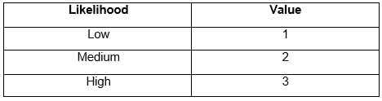

**Figure 8: Likelihood**

There are five options of consequences are:

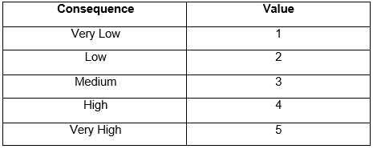

**Figure 9: Consequence**

The following table is of Risk Management:

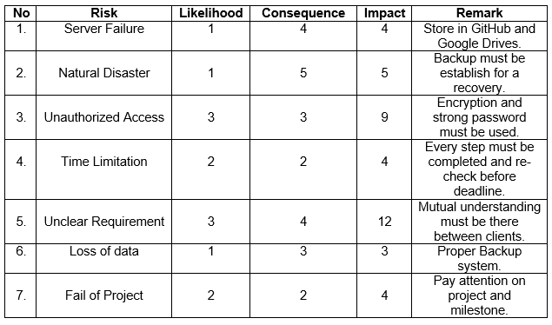

**Figure 10 : Risk Management**